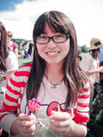

Wanlu Liu

2nd year PhD Candidate, Molecular Biology IDP, UCLA.

B.S. Zhejiang University

Research interests: Genomics, Bioinformatics, Epigenetics, Statistics

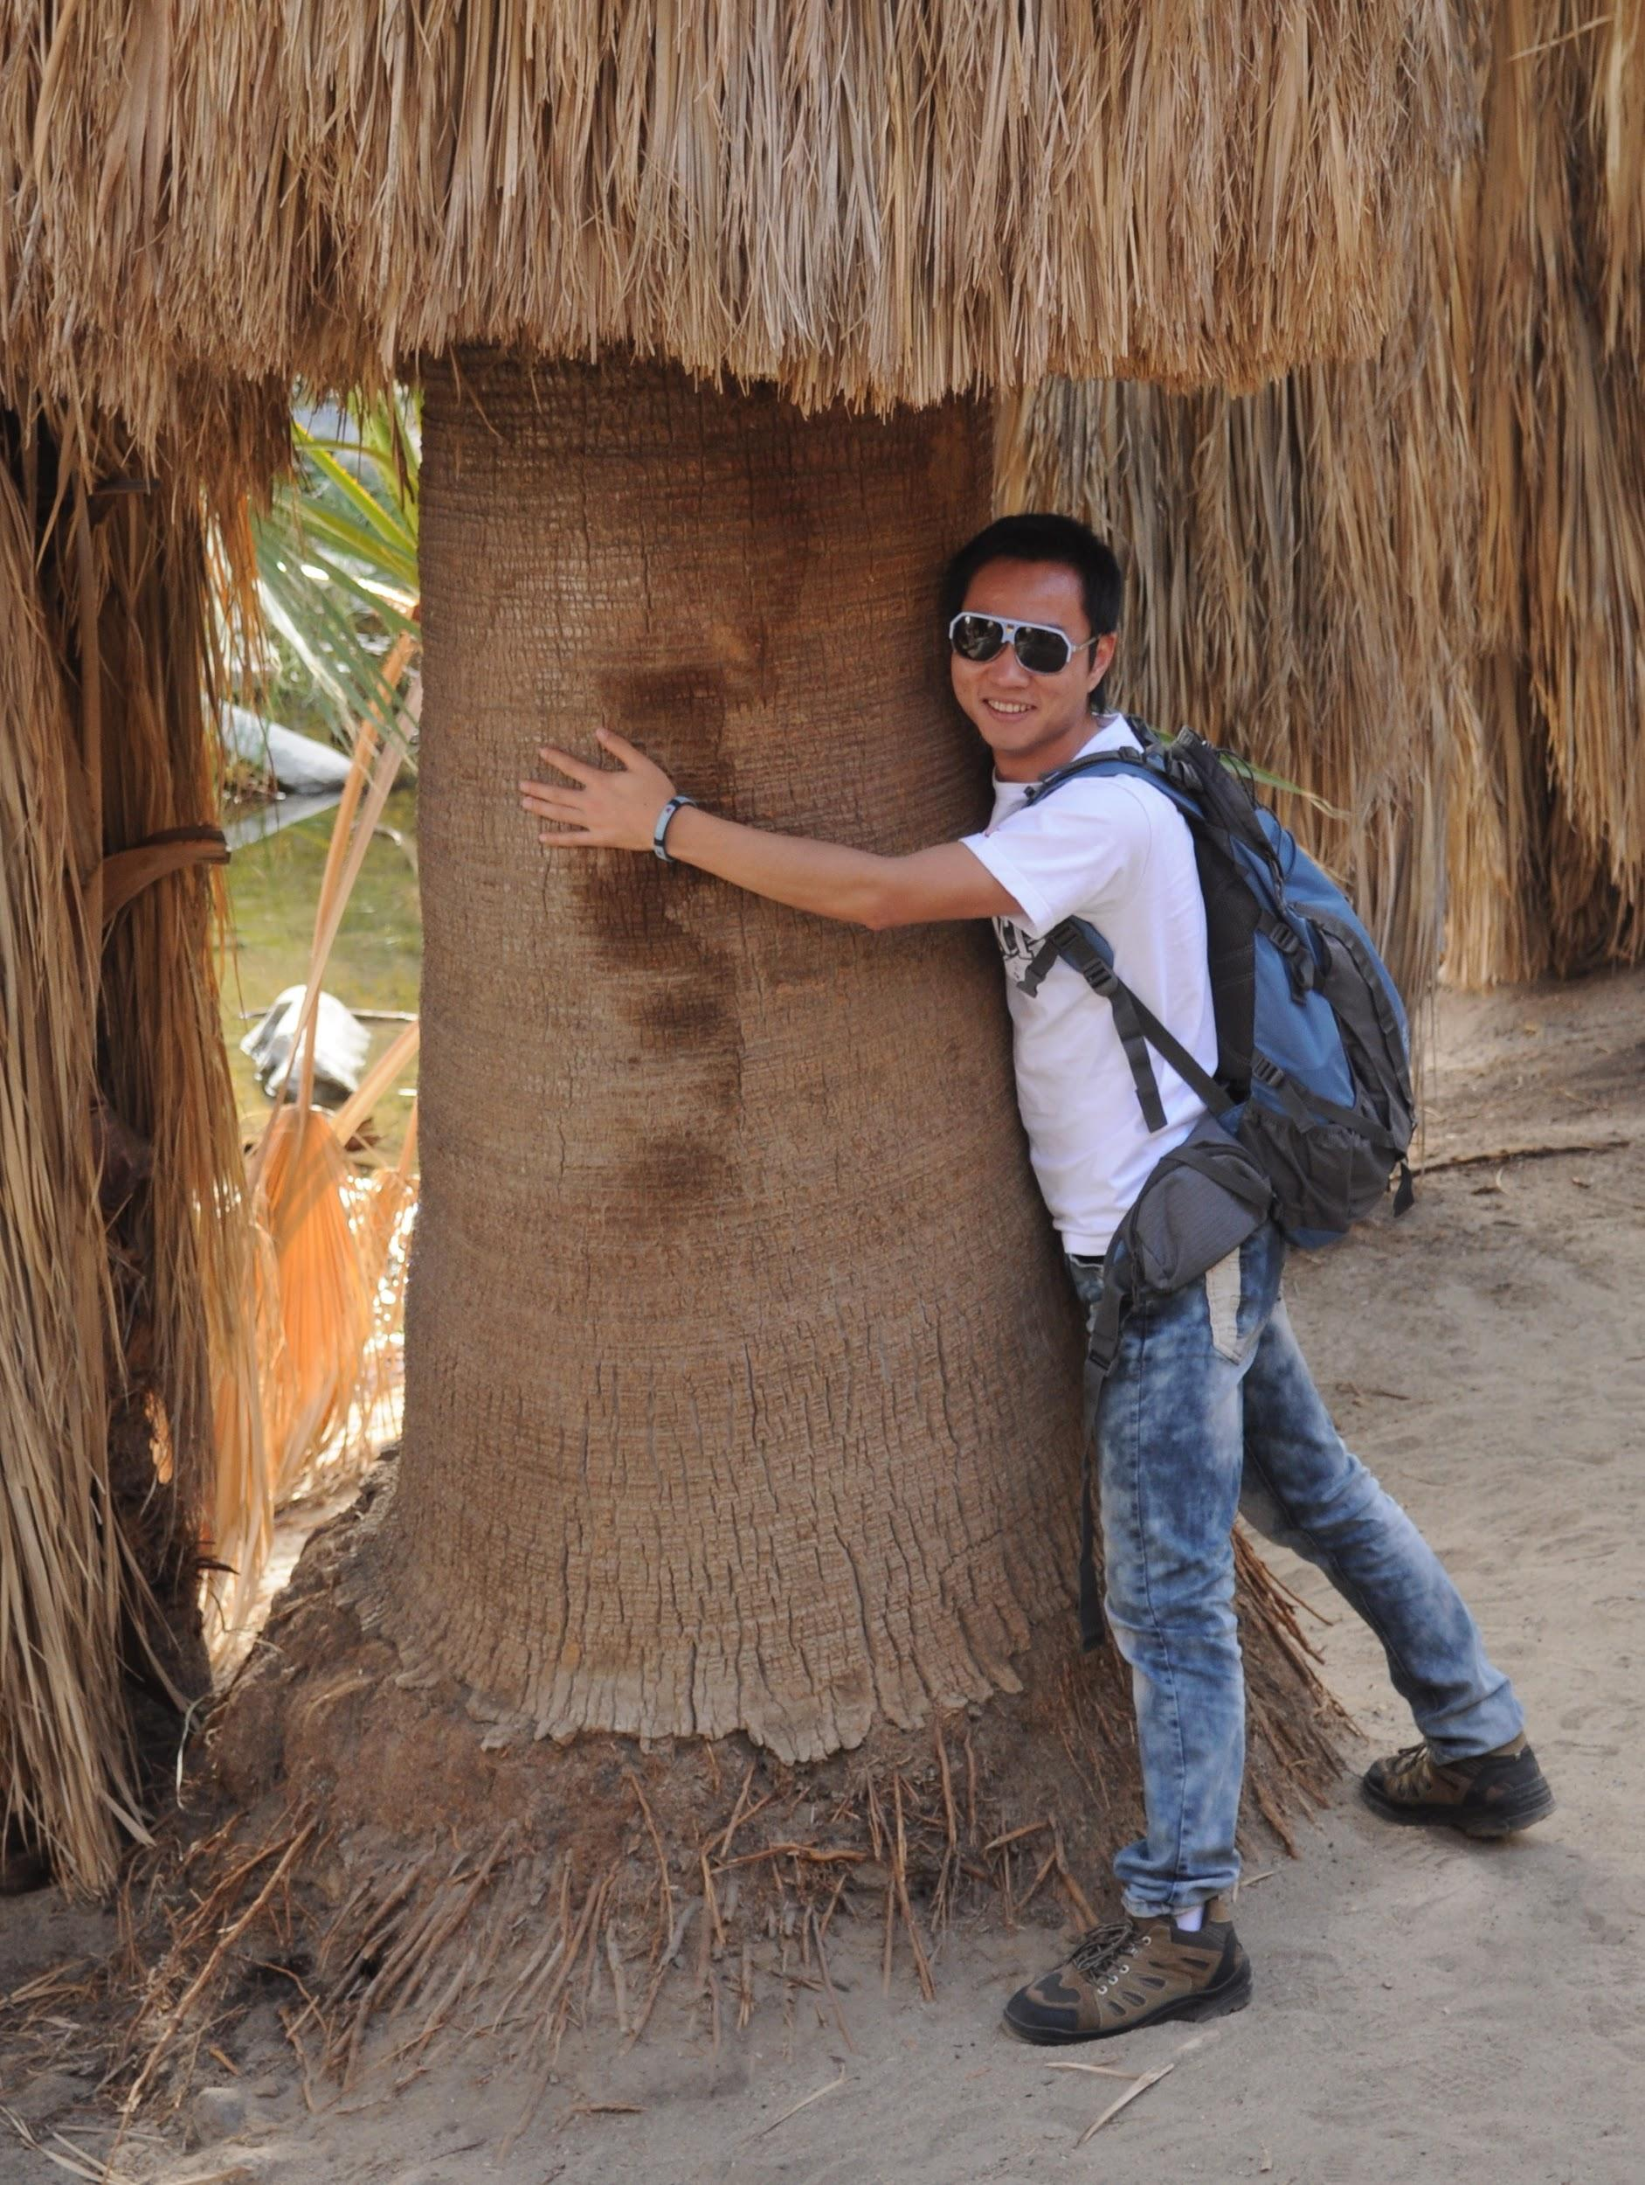

Zhiping Feng

Fifth Year PhD Candidate, Molecular, Cellular & Integrative Physiology，UCLA

B.S. Nankai University

Research Interest:

Biophysics, Optogenetics, Systems Biology

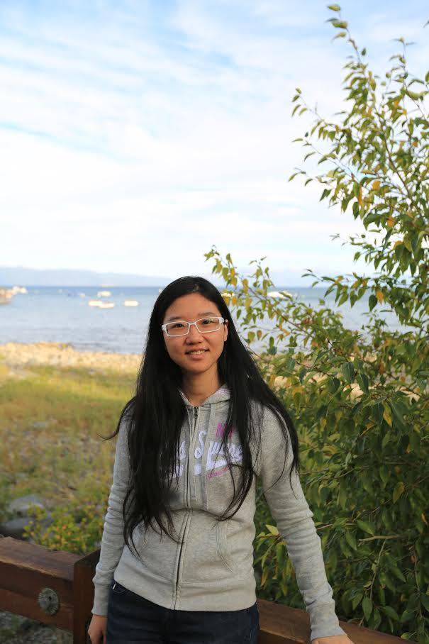

Ying Wang

Fourth Year PhD Candidate, Molecular, Cellular and Integrative Physiology, UCLA

B.S. Nankai University

Research Interests:

Skeletal Muscle Wasting and Regeneration, Aging, Immune Regulation of Muscle Physiology

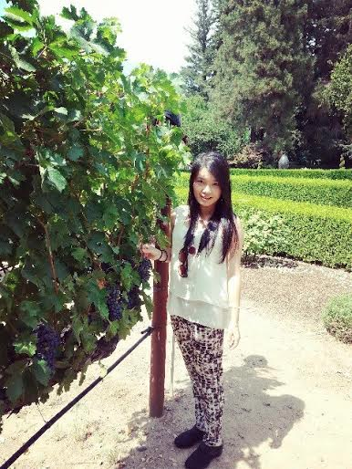

Huixin Zheng

Second Year Master, Luskin School of Public Affairs, UCLA

B.S. Sun Yat-sen University

Research Interests:

Healthcare Policy and International Development

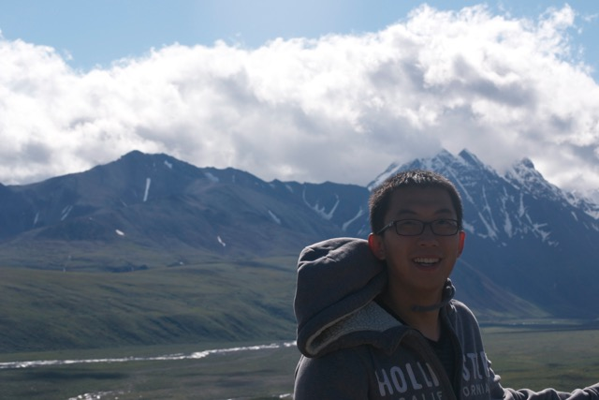

Xiao Yan

Fifth Year PhD Candidate, Pharmacology, Duke University

Visiting Graduate Researcher, Division of Hematology/Oncology, Department of Medicine, UCLA

B.S. Peking University

Research Interests:

Hematopoietic Stem Cell Regeneration and Drug Development

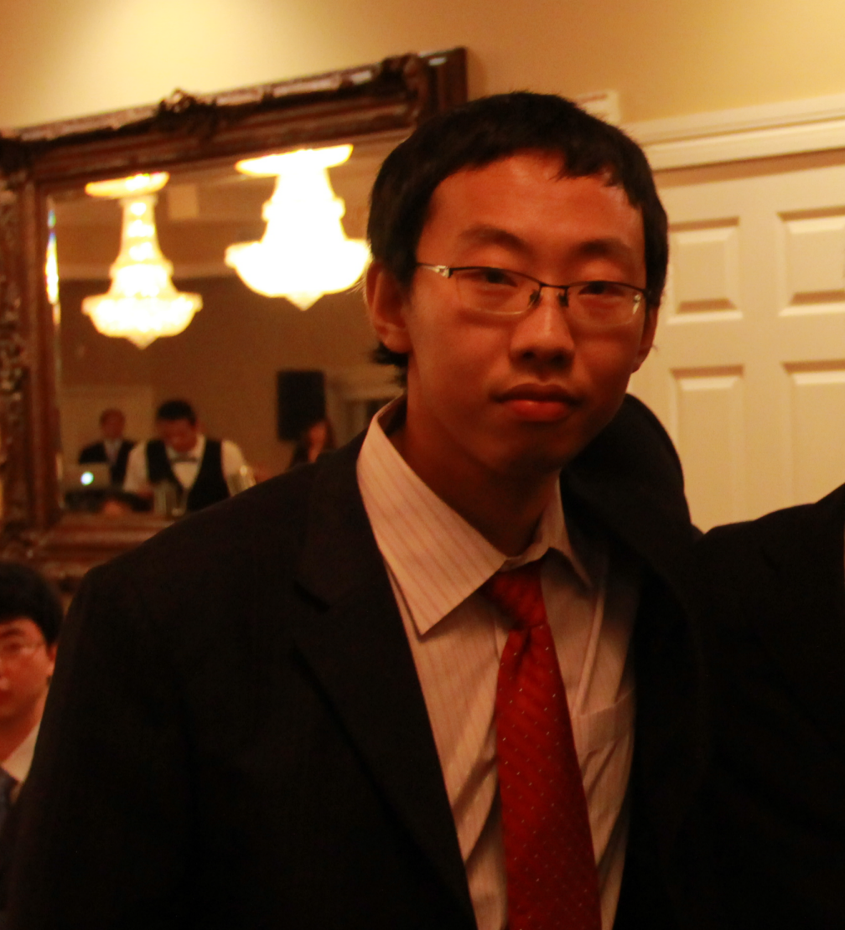

Shi Gao

5th Year PhD Candidate, Computer Science, UCLA

B.S. Zhejiang University

Research Interests:

Semantic Web, Temporal Database, Database Provenance and Data Mining



Ziqi Zang

First Year PhD, Economics, UCLA

B.S University of Minnesota,Twin Cities

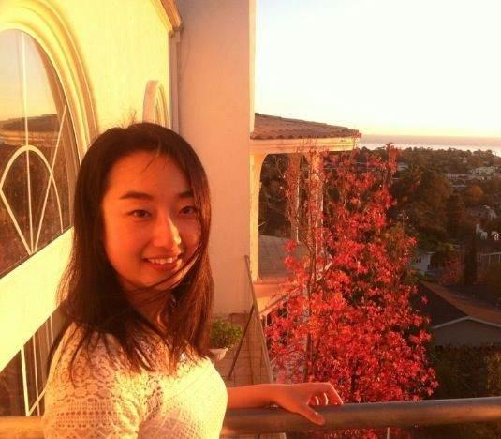

Shanxi Jiang

Second Year PhD, Molecular, Cellular & Integrative Physiology,UCLA

B.S. Fudan University

Research Interests:

Systems Biology, Cardiology, Chromatin Structure, Epigenetics

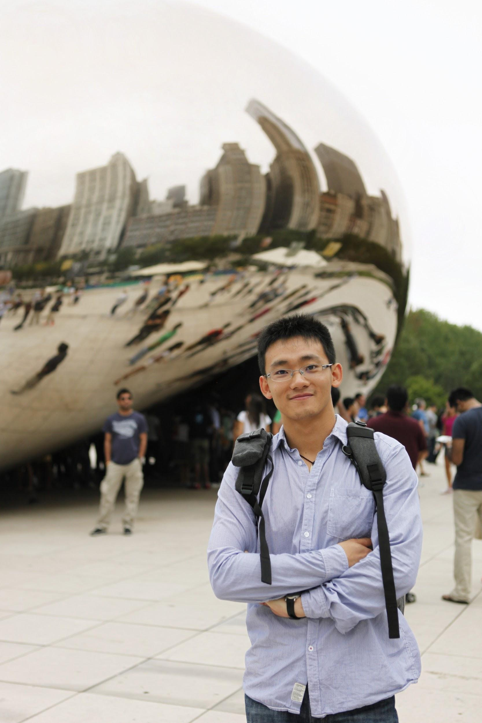

Rui Li

Fifth-year Ph.D. Molecular and Medical Pharmacology, UCLA

Bachelor of Medicine, Zhejiang University

Research Interests:

Inflammation and Carcinogenesis

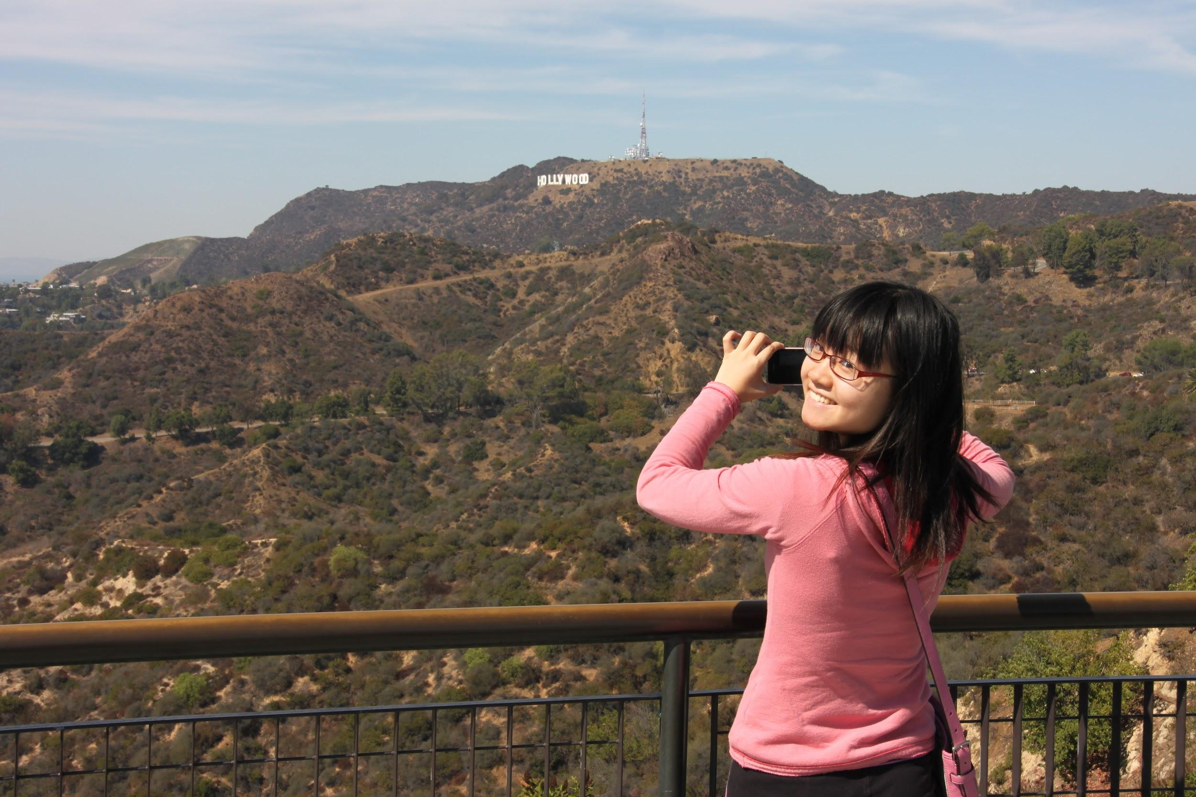

Huan Yang

Fourth Year Ph.D candidate, Molecular, Cellular and Integrative Physiology, UCLA

B.S. Zhejiang University

Research Interest:

Molecular mechanisms of Parkinson’s Disease

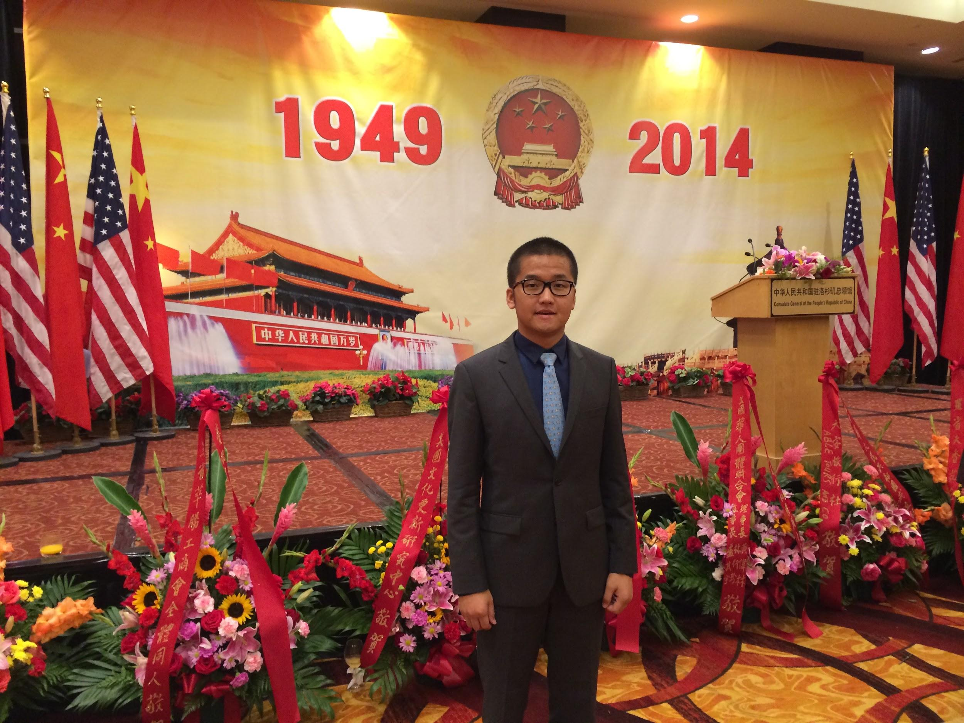

Ting Liu

Fifth Year PhD Candidate, Molecular, Cellular & Developmental Biology, UCLA

B.S. Sichuan University

Research Interests:

Immune Response to Injury, Stem Cell Biology

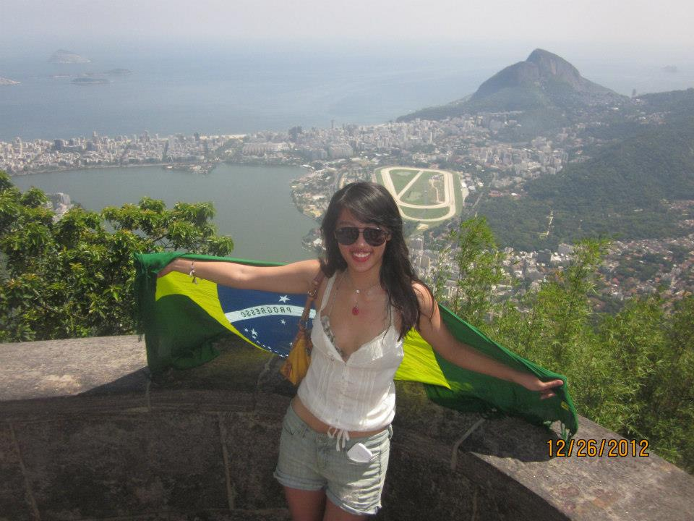

Jin Zhang:

Third Year Ph.D candidate, Molecular and Medical Pharmacology, UCLA

M.D. Nantong Medical School

Research Interest: Mitochondrial Import of BK Channel in the Heart.

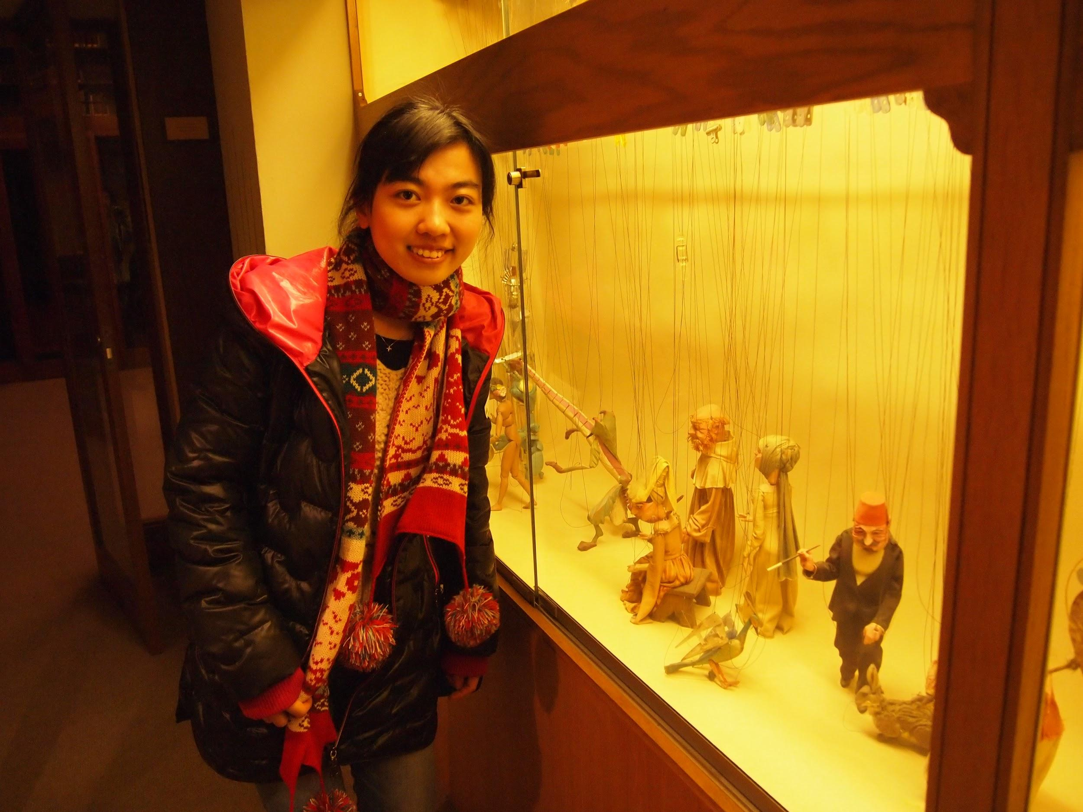

Yan Xu

Master of Landscape Architecture

B.S. Sun-yat-sen University

Research Interest: Landscape design, graphic design

Jiaqi Gu

Second Year Ph.D. in UCLA

Computer Science

B.S. Fudan University

Research Interest: Big Data Systems